Final Project
CSIS 228
By : Majd Thebian
Documentation:
The new Apex Warehouse Management System (ApexWMS) will serve as a comprehensive web-based platform that combines database-driven management with an engaging interactive experience. Unlike the original version, which focused mainly on warehouse tracking and order management, the enhanced system introduces features that mirror real in-game mechanics while maintaining a structured backend for administrators.
At its core, the system will provide secure user authentication where players can create accounts and log in to access personalized features. Once logged in, users can explore multiple sections:
- Legends & Abilities Showcase
Users can browse through all available Apex Legends characters, each with their detailed ability set (passive, tactical, ultimate). This data is fully stored in the database, making it simple for administrators to update or expand when new legends or abilities are introduced.
- Weapons and Items Database
A structured catalog of weapons and heirlooms is provided, allowing users to view item categories, subcategories, damage stats, ammo types, and descriptions. This section makes it easy for fans to compare equipment and learn about different loadouts.
- Interactive Pack Opening System
One of the main highlights of the updated system is the pack opening feature. Users will be able to purchase packs with in-platform credits and open them interactively, with animations resembling the real Apex Legends experience. As the pack opens, unlocked items (weapons, heirlooms, or even legends) are revealed on screen, enhancing the sense of excitement and immersion.
- User Engagement and Expansion
The platform is designed with growth in mind. Future expansions can include additional packs, seasonal updates, or even a trade system where users can exchange unlocked items. The flexible database structure ensures that new content can be integrated without disrupting existing features.
Overall, this new version of ApexWMS combines practical database management (inventory tracking, user accounts, admin tools) with gamified interactive features that create a unique experience for both players and administrators. It is not just a management tool, but a platform that reflects the excitement of the game itself.

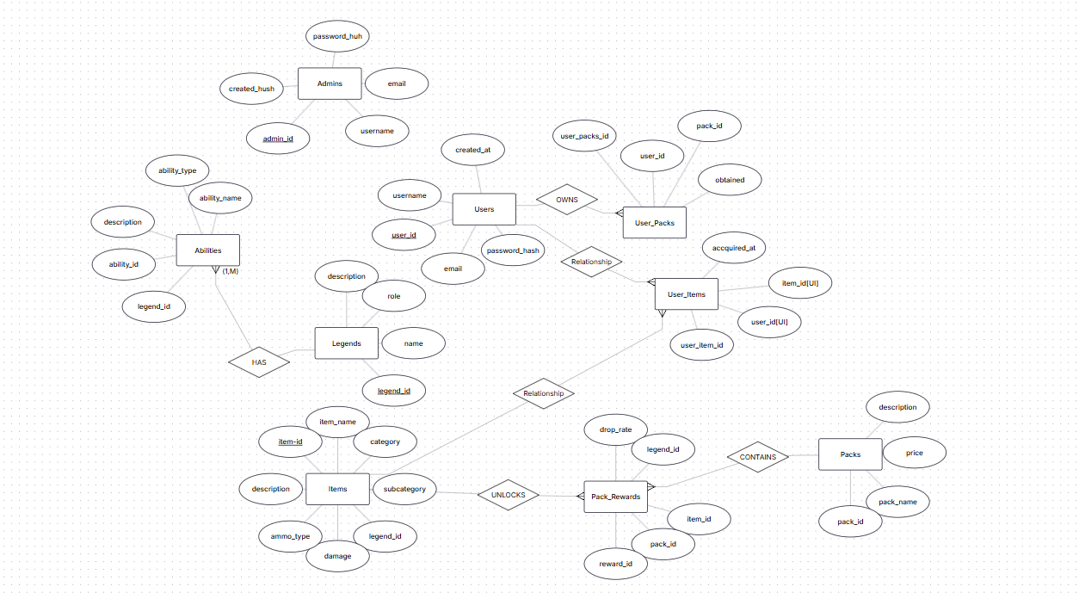
🔹 Database Description
The ApexWMS database is designed to support a web-based system where users can log in, browse legends and their abilities, explore weapons and items, and interact with a gamified pack opening feature. It also includes an admin panel for managing content.
🔹 Key Entities:
- Users
  - Stores registered players’ information for login and personalization.
  - Fields: user_id, username, email, password_hash, created_at.
- Admins
  - Separate table for site administrators.
  - Fields: admin_id, username, password_hash, email, created_at.
- Legends
  - Contains Apex Legends characters.
  - Fields: legend_id, name, role, description.
- Abilities
  - Each legend has 3 abilities (passive, tactical, ultimate).
  - Fields: ability_id, legend_id (FK), ability_name, ability_type, description.
- Items
  - Represents both weapons and heirlooms.
  - Fields: item_id, item_name, category (Weapon/Heirloom), subcategory, legend_id (FK), damage, ammo_type, description.
- Packs
  - Stores pack details (e.g., pack types, prices).
  - Fields: pack_id, pack_name, price, description.
- User_Packs
  - Junction table that tracks which packs a user owns or opened.
  - Fields: user_pack_id, user_id (FK), pack_id (FK), obtained_at.
- Pack_Rewards
  - Stores what items/legends can be unlocked from packs.
  - Fields: reward_id, pack_id (FK), item_id (FK, nullable), legend_id (FK, nullable), drop_rate.
- User_Items
• user_item_id: Unique ID for the record.
• user_id: References the user who owns the item.
• item_id: References the specific item (weapon, heirloom, skin).
• acquired_at: Timestamp when the user obtained it.
• UNIQUE(user_id, item_id): Guarantees the same user cannot own the same item twice.

🔹 Relationships
- Users ↔ User_Packs ↔ Packs → Many-to-Many (users can own many packs, packs can be owned by many users).
- Legends ↔ Abilities → One-to-Many (each legend has multiple abilities).
- Legends ↔ Items → One-to-Many (some items/heirlooms belong to a specific legend).
- Packs ↔ Pack_Rewards ↔ Items/Legends → Many-to-Many (packs can unlock multiple items/legends).
- Admins → can update Legends, Items, Abilities, and Packs (tracked optionally via an admin_actions log).

🔹 Services (CRUD)
These are the backend functions (Node.js/Express APIs) that will interact with your database.
1. Users
- getUsers() → fetch all users.
- getUserById(userId) → fetch one user.
- saveUser(user) → create new user (register).
- updateUser(user) → update profile info or coin balance.
- deleteUser(userId) → remove a user.
2. Admins
- getAdmins() → list admins.
- saveAdmin(admin) → add a new admin.
- deleteAdmin(adminId) → remove admin.
- (Admins will also call other services to manage packs/items/legends).
3. Legends
- getLegends() → fetch all legends.
- getLegendById(legendId) → fetch details (name, passive, tactical, ultimate).
- saveLegend(legend) → add a new legend.
- updateLegend(legend) → edit a legend’s info.
- deleteLegend(legendId) → remove a legend.
4. Items (Weapons / Heirlooms)
- getItems() → fetch all items.
- getItemById(itemId) → fetch details.
- saveItem(item) → add new weapon/heirloom.
- updateItem(item) → modify details.
- deleteItem(itemId) → remove item.
5. Packs
- getPacks() → fetch available packs.
- buyPack(userId, packId) → deduct coins + record transaction.
- openPack(userId, packId) → simulate pack opening + generate reward.
- savePack(pack) → add new pack (admin).
- updatePack(pack) → edit pack details.
- deletePack(packId) → remove pack.
6. Transactions
- getTransactionsByUser(userId) → list all purchases for a user.
- saveTransaction(transaction) → create a new transaction record.
7.User_items
- getUserItems(userId) → get all items owned by a user.
- saveUserItem(userId, itemId) → add a new owned item (when pack is opened).
- deleteUserItem(userItemId) → remove an item from user (if needed, e.g., trading system in future).
- checkItemOwned(userId, itemId) → check if the user already owns an item (used before inserting new rewards).

🔹 Views (Front-End Pages)
These are the EJS/HTML pages (or “views”) that users and admins interact with.
User Views
- Login / Register Page → form for users to log in or sign up.
- Home Page → main navigation (Legends, Weapons, Packs).
- Legends Page → list of legends with click → details page (abilities shown).
- Legend Details Page → shows passive, tactical, ultimate abilities.
- Weapons/Items Page → list of all items with details.
- Packs Page → available packs with “Buy Now” button.
- Pack Opening Page → interactive animation showing reward and added to the owned list..
- Profile Page → shows user coins, owned packs, transaction history.
- User Profile Page → shows all items owned by the user (heirlooms, weapons, skins).
Admin Views
- Admin Dashboard → overview of database (legends, packs, items, users).
- Manage Legends → add/update/delete legends.
- Manage Items → add/update/delete items (weapons, heirlooms).
- Manage Packs → add/update/delete packs.
- Manage Users → list, edit, or delete users.
- Admin Dashboard → (optional) admins can view what items each user owns for management/debugging

